Top 20 SEO Interview Questions & Expert Insights for 2024

SEO has emerged as a growth accelerant for an online business. It has the power to boost online visibility with higher search rankings. When targeted customers search for similar phrases, SEO-optimized web pages get higher rankings.

Statistics reveal that 68% of online experiences begin with a search engine. This means that more and more leads come to the business and spend time on the site. Such strategies will help boost engagement and conversions.

53.3% of all website traffic is organic. Hence, businesses acquire more customers online with the help of tactical SEO campaigns.

As more and more purchase decisions happen online, businesses benefit from higher rankings. They get a competitive advantage over others and boost business revenues.

You may aspire to land a coveted job within this space. Let me help you in getting the first step right. In this post, I will share some commonly asked questions and answers during interviews for SEO positions. Read about them below and get a massive headstart over other candidates in the interview.

Let us read about this topic below.

20 Questions & Answers for SEO Interviews

[1] What is SEO?
The process of improving a website's exposure in search engine results to facilitate visitors' discovery of pertinent material is known as search engine optimisation. SEO strategies concentrate on drawing in organic traffic or users that discover a website through unpaid search results. This is an affordable approach to produce leads and raise a website's prominence.

It is an 'organic,' 'free,' and 'natural' result-oriented tool. There are several optimisation techniques and actions. Users should ensure that your site is SEO-friendly and ranks for desired keywords.

[2] What Is An Organic Result?
Search results are shown in an organic format according to quality, relevancy, and additional ranking factors. These are one of the two categories of SERP search results. Organic results are unpaid, often called "free results" or "natural outcomes." The organic results are ranked according to several factors.
The sponsored results are shown above the organic results. Google cannot be charged to affect organic results. Its results can be enhanced By assuring better data and enabling user interaction.

[3] What Is Off-Page vs On-Page SEO?

On-page SEO contains the factors you can control, such as:
- Content
- Page structure
- Keywords
- Load time
- Internal linking
Off-page SEO is those factors you have zero control over, for example, backlinks.

[4] Could You Outline Any Crucial Factors Influencing Google’s Ranking?
The following are the primary Google Ranking Factors:
- Content Freshness
- HTTP
- Quality Content
- Technical SEO
- Domain Strength
- Content-Type
- Content Depth
- Social Signals
- Domain Authority
- Quality & Relevant Backlinks
- Mobile First
- Page Speed
- Brand Strength
- User experience
- Schema Code

[5] Which Tools Are You Most Often Using for SEO?
SEO tasks may be made more accessible with various tools. The excellent one to choose will depend on your requirements.
- ahref
- sem haste
- kwfinder
- quack SEO
- Moz

[6] What Relationship Is There Between SEO and SEM?
The primary difference is that you must pay for SEM, while SEO is free. Pay-per-click and display ads are included in SEM. Even though they differ significantly from one another, they function best together.

[7] Where Are Keywords Used?
Given that you need to know where to employ keywords, this is one of the most crucial SEO interview questions in 2024.
The keywords appear on a page in several locations. For on-page SEO optimisation, we should use keywords in:
- Meta description
- Subheadings
- Image alt tag
- Meta title
- Anchor Text
- URL
- Page Content

[8] Could You Provide Me With Any Long-Tail Keyword Examples?
Here are some excellent long-tail keyword examples:
- What is local SEO and how does it work
- Best digital marketing course in India
- Best laptops in India under 70000
- Learn content writing from scratch
- Make pizza at home without an oven

[9] But What Does SEO Keyword Density Mean?
The number of times a keyword appears in the body of an article or web page relative to the total number of words on the page is known as keyword density.
It is displayed as a percentage. For instance, if you use a term five times in a 500-word piece, it is 1% density.

[10] Google Autocomplete: What is it?
The Google Search bar automatically suggests certain things for us to look up when we search for anything. This feature aims to make users' searches easier and faster to finish.
The autocomplete tool is helpful for SEO since it reflects suggestions based on what users search for on Google. We can determine consumers' queries about our subject or company.

[11] How to Check Keyword Density?
The keyword density checker formula allows us to determine the percentage of keywords used in the content. Follow the keyword density formula. You divide the number of times a keyword occurs by the word count of the article or your web content. After that, multiply the result by 100. It will give you the keyword density percentage.

[12] What Is Meta Description?
The links that show up after a question is placed in a search engine contain a 155 to 160-character snippet beneath it, which describes the site page's content. This snippet is known as a meta description.

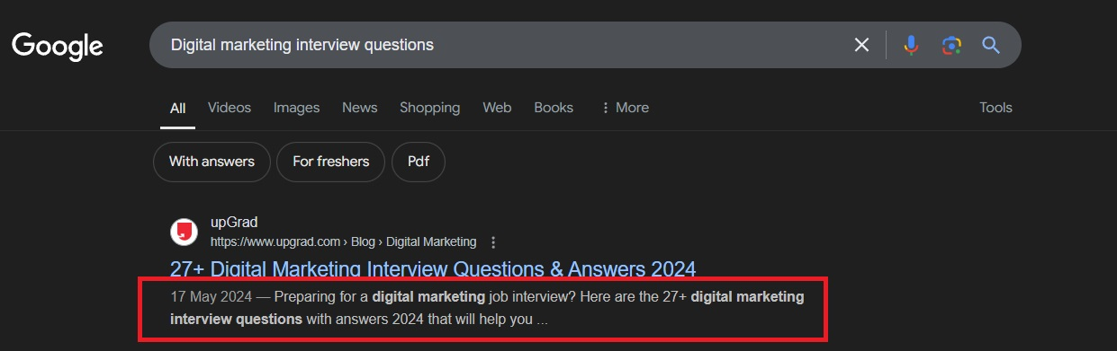

[13] Explain Organic And Paid Traffic
Organic traffic refers to people visiting your site through the search engine query. Referral traffic comes to your website via hyperlinks on another site and not through a search engine. Traffic that reaches your website through 'paid' social media and search engine marketing initiatives is known as paid traffic.

[14] What Is the Limit of the Description & Title Tag?
Meta Description - A 150–160 character maximum is advised for this section.
The recommended character limit for the title tag is 50–60.

[15] What Is Link Building? Why Does It Matter?
Inserting links from other websites into your websites is called link building. Search engines like Google use ranking factors. One of the important ranking factors is link building. Google says that links prove that your site is worth the read. Therefore, it is a critical SEO practice.

[16] What Are Some Common SEO Mistakes to Avoid?
Some of the most common SEO mistakes are:
- recurring usage of the same anchor link
- badly written content
- not targeting the correct keywords
- not using creative titles and meta descriptions

[17] What Do You Mean by White Hat SEO?
This is an essential SEO interview questions and answers. As you already know, white hat SEO refers to the method and techniques used in increasing website ranking within the boundaries of Google guidelines.

It is about creating search engine-friendly websites with a great user experience. It also creates quality content, as its users should need reference and value in this content. It helps them earn good-quality links and thus. It differs from black hat SEO. It does not employ shady tactics to deceive search engines into giving it short-term results.

[18] What Is Crawling?
Search engines use crawling to find web pages online. Search engine bots crawl through your website pages by following links between them and downloading new web pages to put in their index.

[19] What Is A Sitemap?
A sitemap is a file listing all the essential pages on a website that you want search engines to crawl and rank in search results. It is crucial because it makes it easier for quick page discovery for Google.

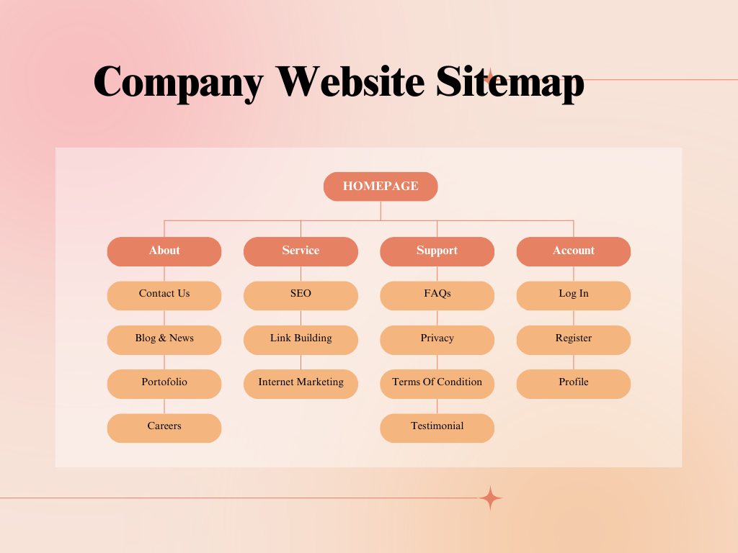

[20] Do You Want to Ask Us Any Questions?
Some interview questions to include are:
- Are there some other assumptions separated from the referenced expected set of responsibilities?
- What are the SEO tools that the organisation utilises?
- What might you want to impart to me on helpful, professional learning experiences in your organisation?
- Does the organisation/office permit lateral job changes?
- Do you have an enlistment program?
- How does the organisation/office support SEO learning and improvement?

In Conclusion
SEO is necessary for everyone who wants to succeed in digital marketing. This article offers information on off-page and on-page SEO tactics. It clarifies that to succeed in SEO, you need quality content, practical keyword usage and link-building practices. That means that one can understand how the search engine result pages work. And also which ranking factors determine which websites will rank top and which will not.

Indeed, that can substantially improve a website’s visibility, organic traffic and profits. On an introductory note, they avoid common SEO mistakes for better performance and user engagement.
The topic of SEO is rapidly changing. However, staying updated on the latest SEO trends and tools will equip marketers to perform well within those trends and gain audience growth. An excellent SEO foundation is integral to any business’s online success.

FAQs
[1] What is the first step to getting started in SEO?
Educate yourself on the basics of SEO from online courses. You can also learn from blogs and hands-on website optimisation.

[2] Who is an SEO Specialist?
An SEO Specialist is experienced in the team. They do the required work to create new strategies. And even help in revamping the present SEO strategies for better results.

[3] What is the average SEO salary in India?
According to PayScale, the average salary of an SEO professional in India is around Rs.285,875. Salary is based on skills and experience.

[4] Can I get an SEO career without a degree?
You don’t need a degree, but knowledge in digital marketing, analytics or computer science does help.

[5] What skills are required in an SEO career?
Keyword research
Data analysis
Content creation
Technical SEO and more.

[6] Is SEO a promising long-term career?
SEO is a growing field that has a high demand across different industries.

[7] Is SEO a freelance career?
Many SEO professionals work as freelancers or consultants for companies of all sizes.

